Lab: Lists Basics
Problems for in-class lab for the Python Fundamentals Course @SoftUni.
Submit your solutions in the SoftUni judge system at https://judge.softuni.bg/Contests/1724/Lists-Basics-Lab.

Strange Zoo
You are at the zoo and the meerkats look strange. You will receive 3 strings: (tail, body, head). Your task is to re-arrange the elements in a list, so that the animal looks normal again: (head, body, tail).

Example
Input | Output
my tail  my body seems on place  my head is on the wrong end! | ['my head is on the wrong end!','my body seems on place','my tail']
tail  body  head | ['head', 'body', 'tail']

Hints
We start by reading the three parts of the body:
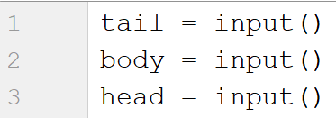
Then, we create a list containing those three elements:
We swap the elements and print the list:

Courses
You will receive a single number n. On the next n lines you will receive names of courses. You should create a list of courses and print it.

Example
Input | Output
2  PB Python  PF Python | ['PB Python', 'PF Python']
4  Front-End  C# Web  JS Core  Programming Fundamentals | ['Front-End', 'C# Web', 'JS Core', 'Programming Fundamentals']

Hints
We read the number n from the console and we create an empty list:
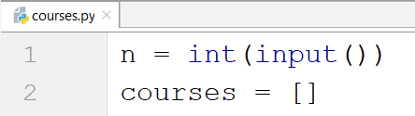
Then, we create a loop which reads each course and adds it to the list:
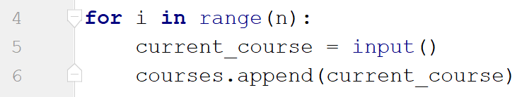
Finally, we print the list:
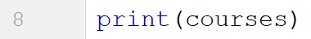

List Statistics
You will be given a number n. On the next n lines you will receive integers. You should create and print two lists:
- One with all the positives (including 0) numbers
- One with all the negatives numbers
Finally, print the following message: "Count of positives: {count_positives}. Sum of negatives: {sum_of_negatives}"

Example
Input | Output
5  10  3  2  -15  -4 | [10, 3, 2]  [-15, -4]  Count of positives: 3. Sum of negatives: -19

Hints
We start by reading the number n:
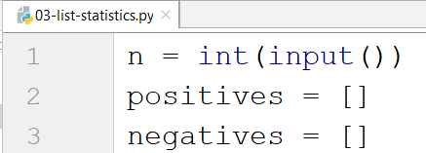
Then, we create a loop which reads the current number and checks if it is positive or not:
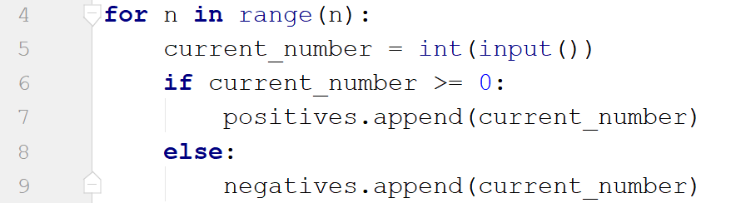
- If it is, we add it to the list of positive numbers.
- If it is not, we add it to the list of negative numbers.
Then we print the three lines:
- To get the count of the positives we can use the len function.
- To get the sum of the negatives we can use the sum function.

Search
You will receive a number n and a word. On the next n lines you will be given some strings. You should add them in a list and print them. After that you should filter out only the strings that include the given word and print that list too.

Example
Input | Output
3  SoftUni  I study at SoftUni  I walk to work  I learn Python at SoftUni | ['I study at SoftUni', 'I walk to work', 'I learn Python at SoftUni']  ['I study at SoftUni', 'I learn Python at SoftUni']
4  tomatoes  I love tomatoes  I can eat tomatoes forever  I don't like apples  Yesterday I ate two tomatoes | ['I love tomatoes', 'I can eat tomatoes forever', "I don't like apples", 'Yesterday I ate two tomatoes']  ['I love tomatoes', 'I can eat tomatoes forever', 'Yesterday I ate two tomatoes']

Hints
We start by reading the number n and the word we would search for. Then, we create our empty list:
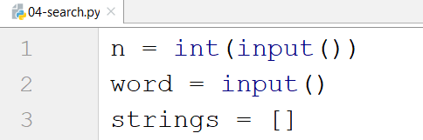
We create a loop which adds all the strings in our list. After that, we print it:
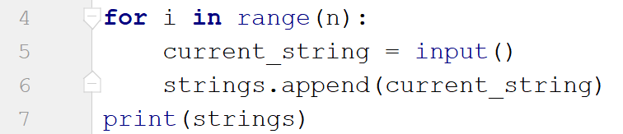
Finally, we create another loop to remove the strings we do not need by iterating through the strings reversed (so we don't skip elements when removing) and print the list again:
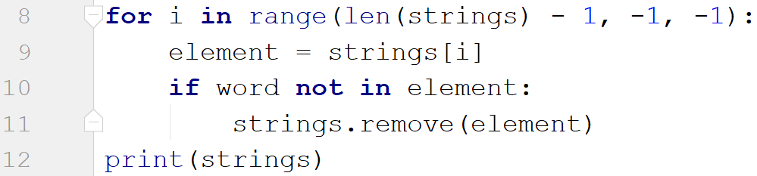

Numbers Filter
You will receive a single number n. On the next n lines you will receive integers. After that you will be given one of the following commands:
- even
- odd
- negative
- positive
Filter all the numbers that fit in the category (0 counts as a positive and even). Finally, print the result.

Example
Input | Output
5  33  19  -2  18  998  even | [-2, 18, 998]
3  111  -4  0  negative | [-4]

Hints
First, we read the number n, then, we create the numbers list and the filtered list:
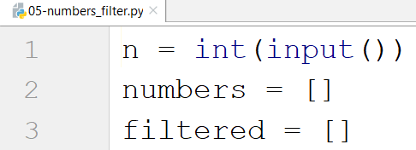
We create a loop which reads all the numbers and adds them to the list:
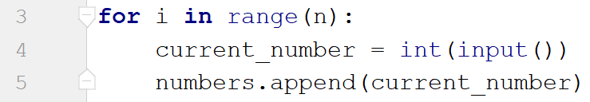
Then, we read the command and check for all the cases:
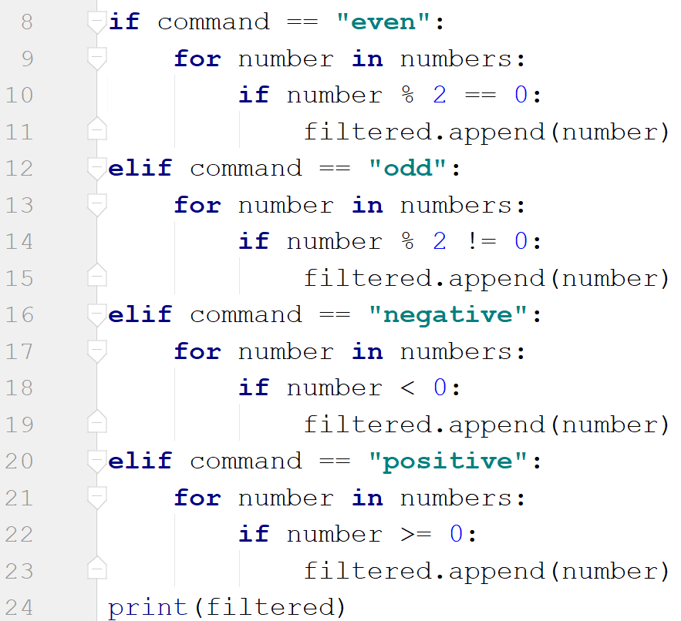
- Finally, we print the filtered list.

